DATABASE MANAGEMENT SYSTEMS
PROJECT REPORT
FESTFLOW
Full-Stack College Event Management System
A Database Design, Implementation and Verification Study

SUBMITTED BY
S Sathyan, S Sarvesh, N Sriram
Register Number: 25BCE1683,25BCE1702,25BCE1619
Faculty Supervisor: Dr. Geetha S
School : SCOPE
Institution: VIT Chennai Campus

ER Diagram :
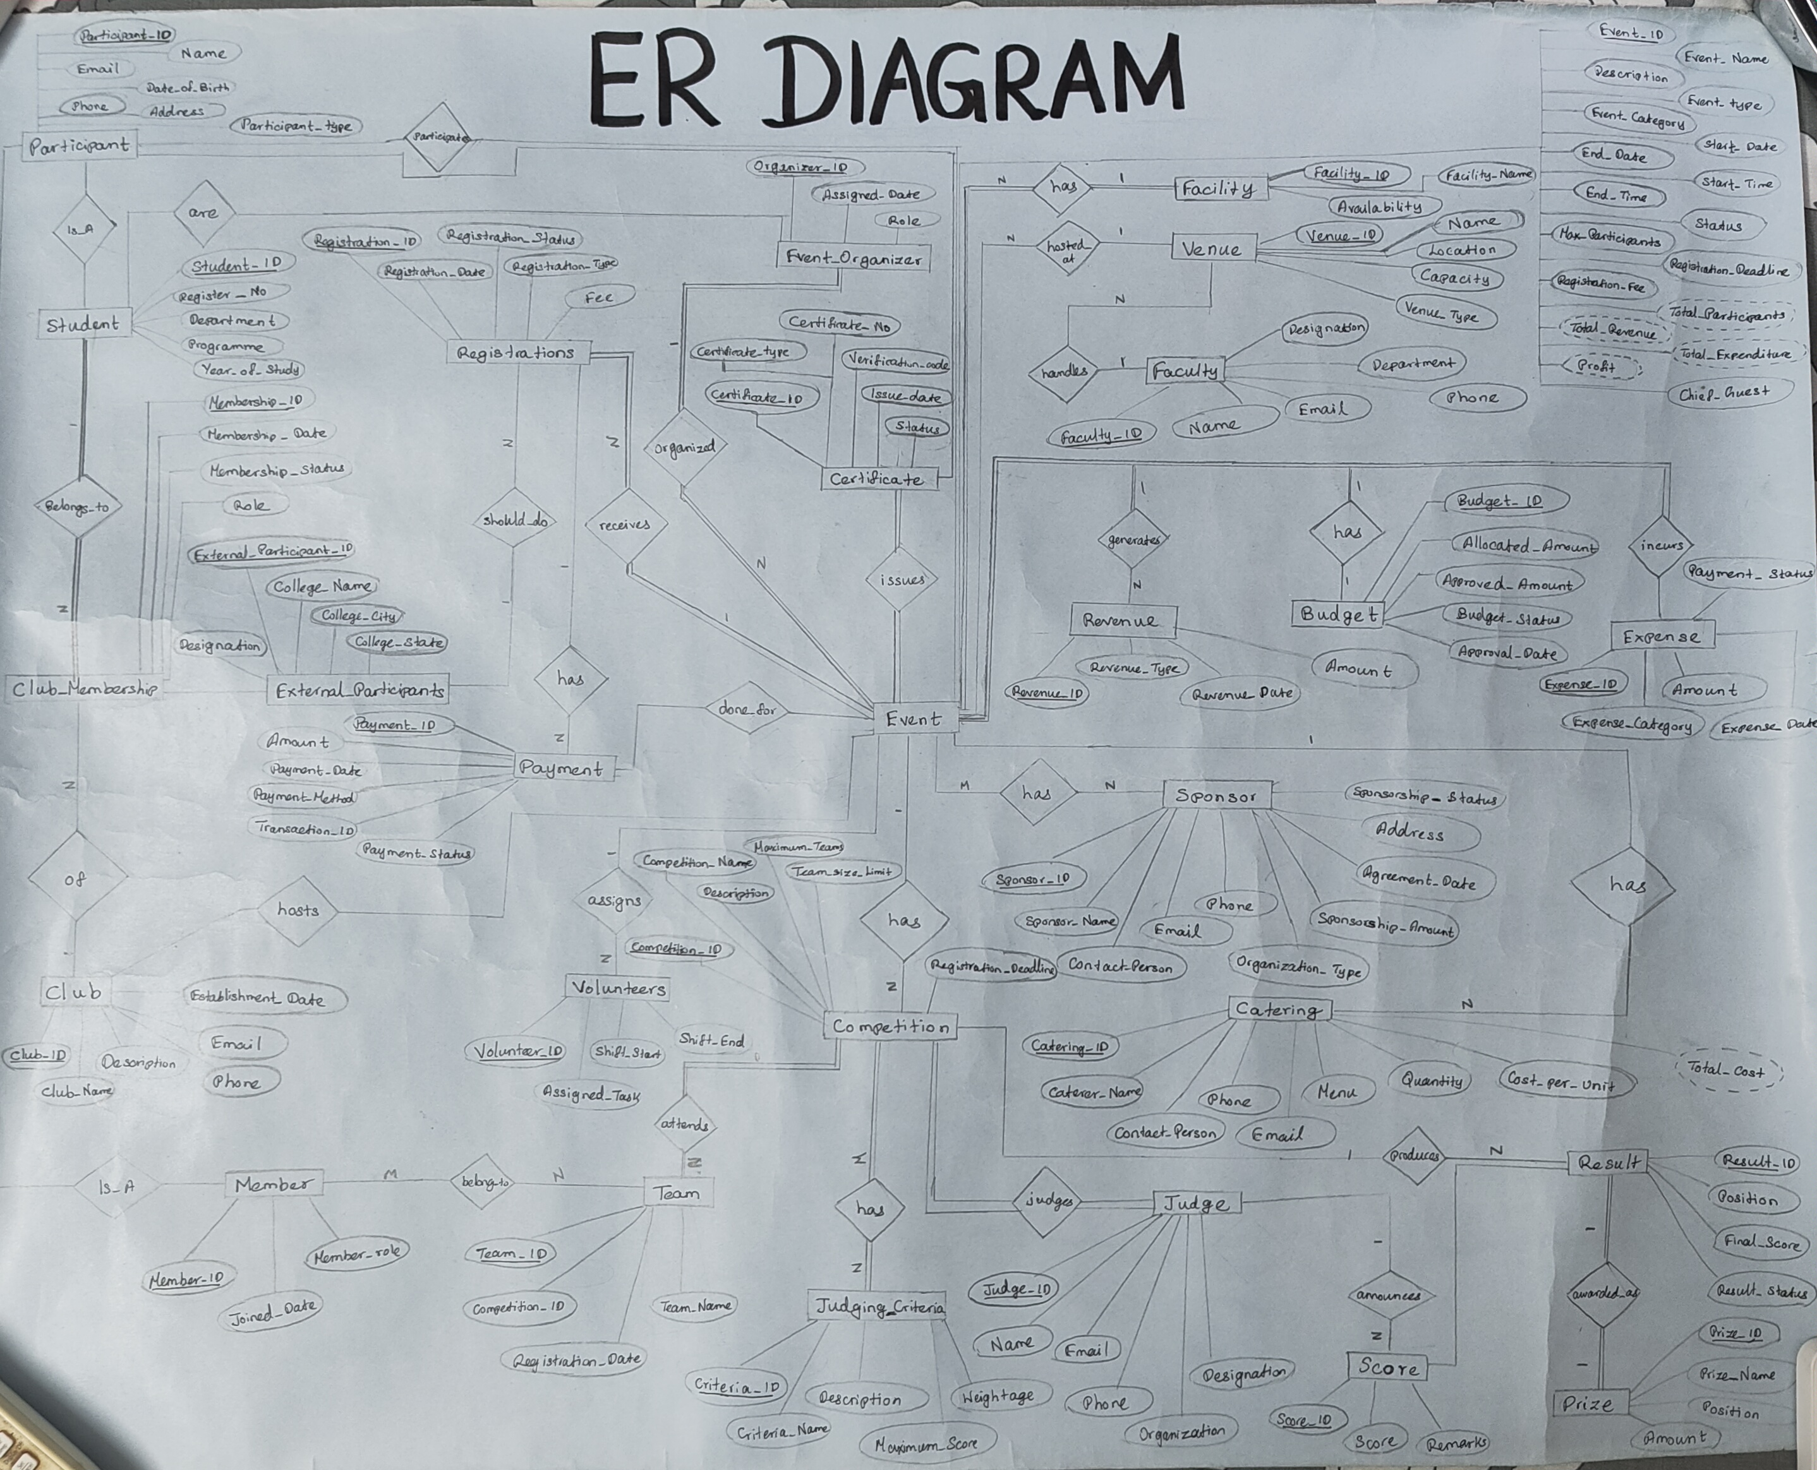

Abstract
FestFlow is a full-stack college event management platform designed to bring event discovery, club administration, registration, ticketing and financial tracking into one system. The application uses a four-role hierarchy—student, organizer, faculty and administrator—with server-side checks that restrict actions to the clubs each user is permitted to manage. The active application is built with React, Node.js and Express, with MongoDB Atlas as its live database and Mongoose for schema validation and data access. Compound unique indexes help prevent duplicate registrations, while aggregation pipelines calculate financial summaries and seat availability from stored records. The project also includes relational ANSI SQL reference files for DBMS coursework; these are academic artifacts and are not the database engine used by the running application. Testing recorded 53 successful automated tests, and the frontend production build completed without errors.
Index Terms— Database management, MongoDB, normalization, event management, role-based access control, compound indexes, aggregation.

1. Introduction
College events are often coordinated by several clubs and departments at the same time. Registration lists, venue bookings, budgets and volunteer assignments can become difficult to maintain when each team uses separate spreadsheets or messaging channels. These arrangements also make it harder to prevent duplicate registrations, protect club-level financial information and keep venue capacity accurate.
FestFlow addresses these problems through a centralized web application. Students can discover events and manage their passes; organizers manage activities for their assigned clubs; faculty supervise clubs and appoint organizers; and administrators oversee campus-wide configuration. The database layer supports these workflows through structured Mongoose schemas, references between related records, validation rules, compound indexes and aggregation queries.

2. Problem Statement and Objectives
The project aims to reduce errors and access-control problems that arise when event information is maintained in separate systems. The main requirements are to prevent cross-club data access, avoid duplicate registrations, respect venue capacity, maintain transparent event finances and support faculty oversight.
- Provide one place to publish, discover and manage college events.
- Enforce role-based permissions and club-scoped authorization on the server.
- Prevent duplicate event registrations with a unique user–event index.
- Calculate ticket availability, catering costs and event profit from current records rather than storing redundant totals.
- Support faculty appointment of organizers and administrator provisioning of faculty accounts.
- Maintain digital passes, certificates, payments, volunteer records, feedback and competition results.

3. System Architecture and Technology
FestFlow follows a three-tier client–server architecture. The React frontend sends JSON requests to an Express REST API. Middleware verifies the user’s JWT, checks the required role and applies club-level authorization before controllers access MongoDB through Mongoose.
Layer | Technology | Role in the system
Client | React 18, Vite, React Router, Axios, Tailwind CSS | Pages, role-specific dashboards, forms and API requests.
API / server | Node.js 24, Express 4 | REST endpoints, authentication middleware, authorization and business logic.
Data layer | MongoDB Atlas, Mongoose 8 | Document persistence, schema validation, indexes, references and aggregations.
Security / support | JWT, bcryptjs, CORS, dotenv, Morgan | Session tokens, password hashing, origin controls, environment configuration and request logging.

3.1 Request Flow
- The user performs an action in the React interface, such as registering for an event or viewing club finances.
- Axios sends a request to the corresponding Express API endpoint with a bearer token where authentication is required.
- Authentication middleware verifies the token and loads the active user; role and club-authorization middleware check whether the action is permitted.
- The controller validates the request and reads or updates the relevant MongoDB documents through Mongoose.
- The API returns a success or error response, and the frontend updates the displayed information.

3.2 Technology Summary
The client is built with React 18.3.1 and Vite 6.0.3. The server uses Node.js and Express 4.21.2. MongoDB Atlas is the live cloud database, accessed through Mongoose 8.9.5. JWTs are used for session authentication and bcryptjs hashes passwords before storage. The exact installed package versions are listed in the project’s technical reference.

4. Functional Modules
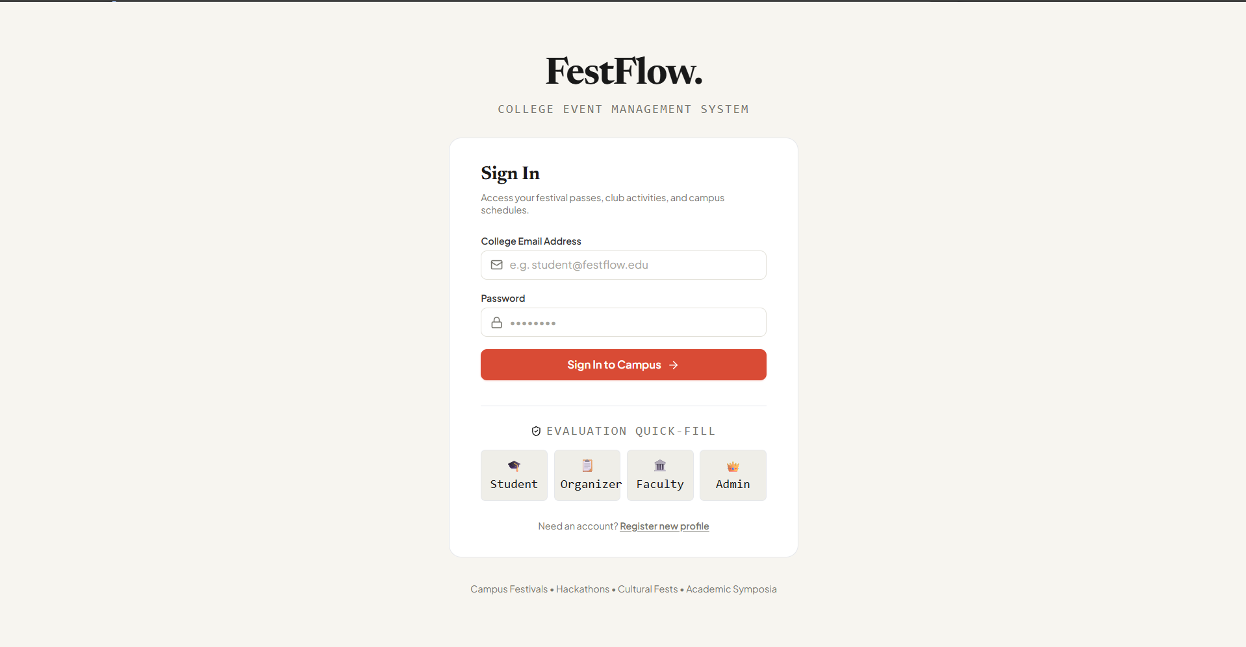
Figure 1. FestFlow sign-in screen for accessing role-specific campus portals.
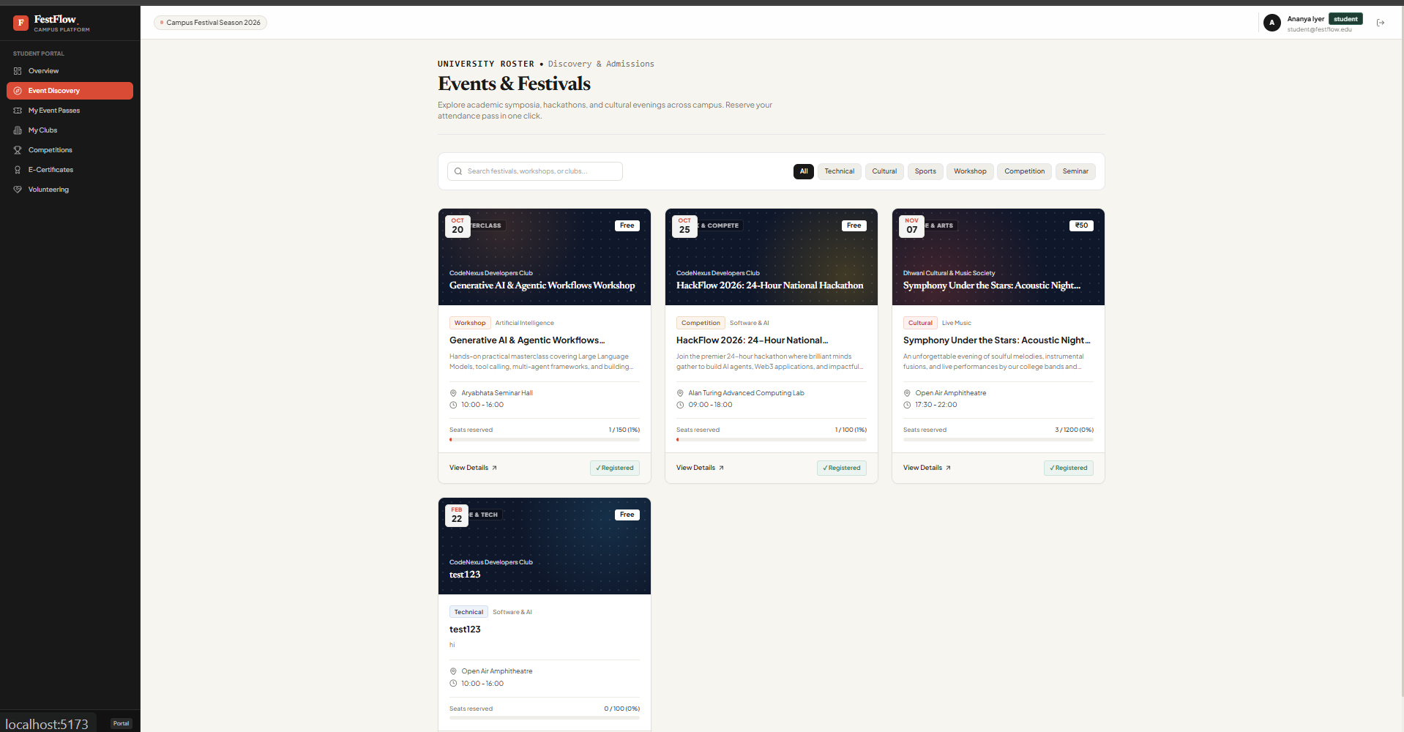
Figure 2. Student event discovery page showing upcoming campus events.
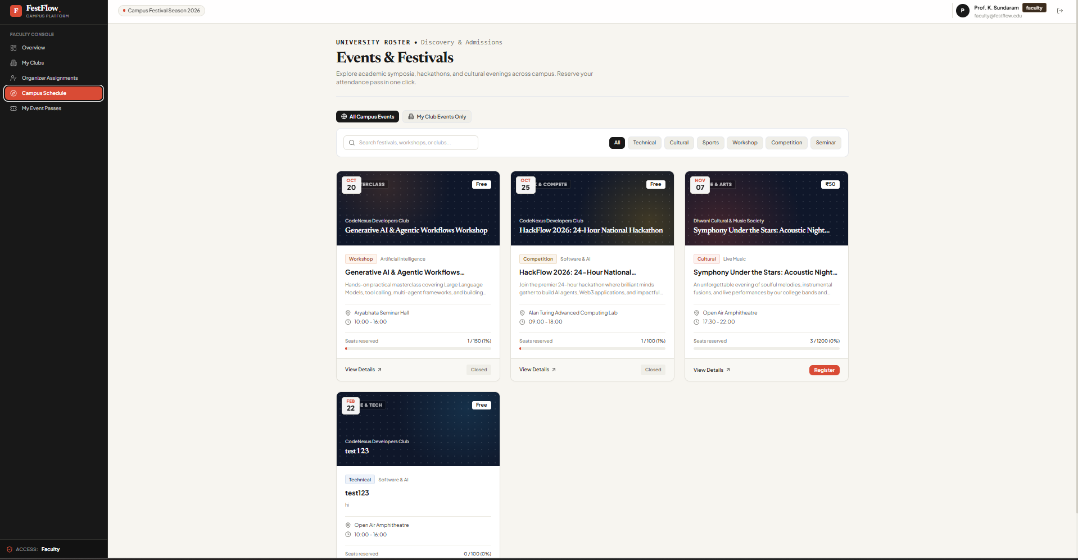
Figure 3. Campus event discovery page with event cards and category filters.
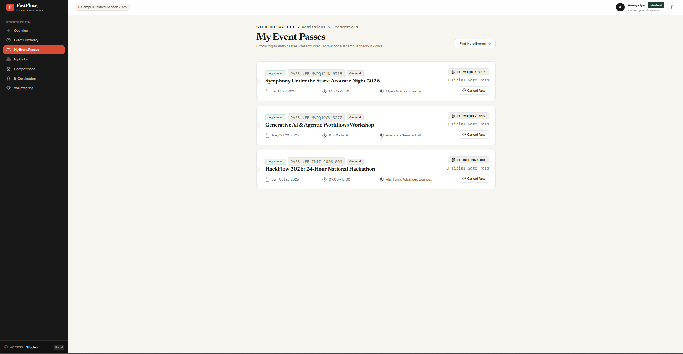
Figure 4. Student digital event passes with registration and venue details.
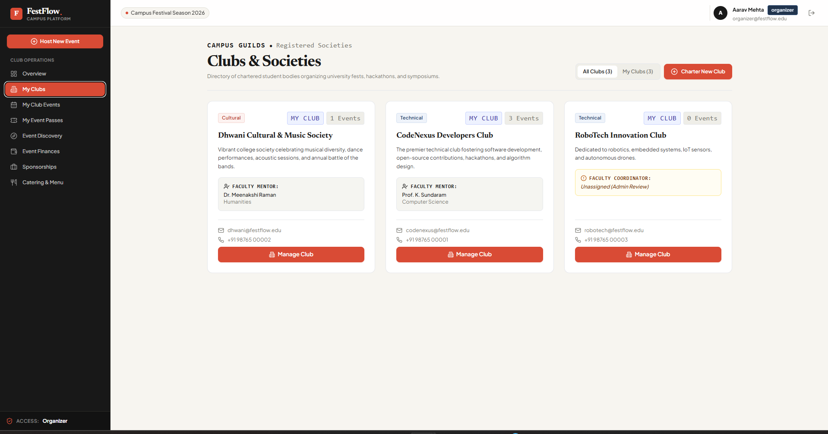
Figure 5. Club directory showing registered societies and faculty mentor information.
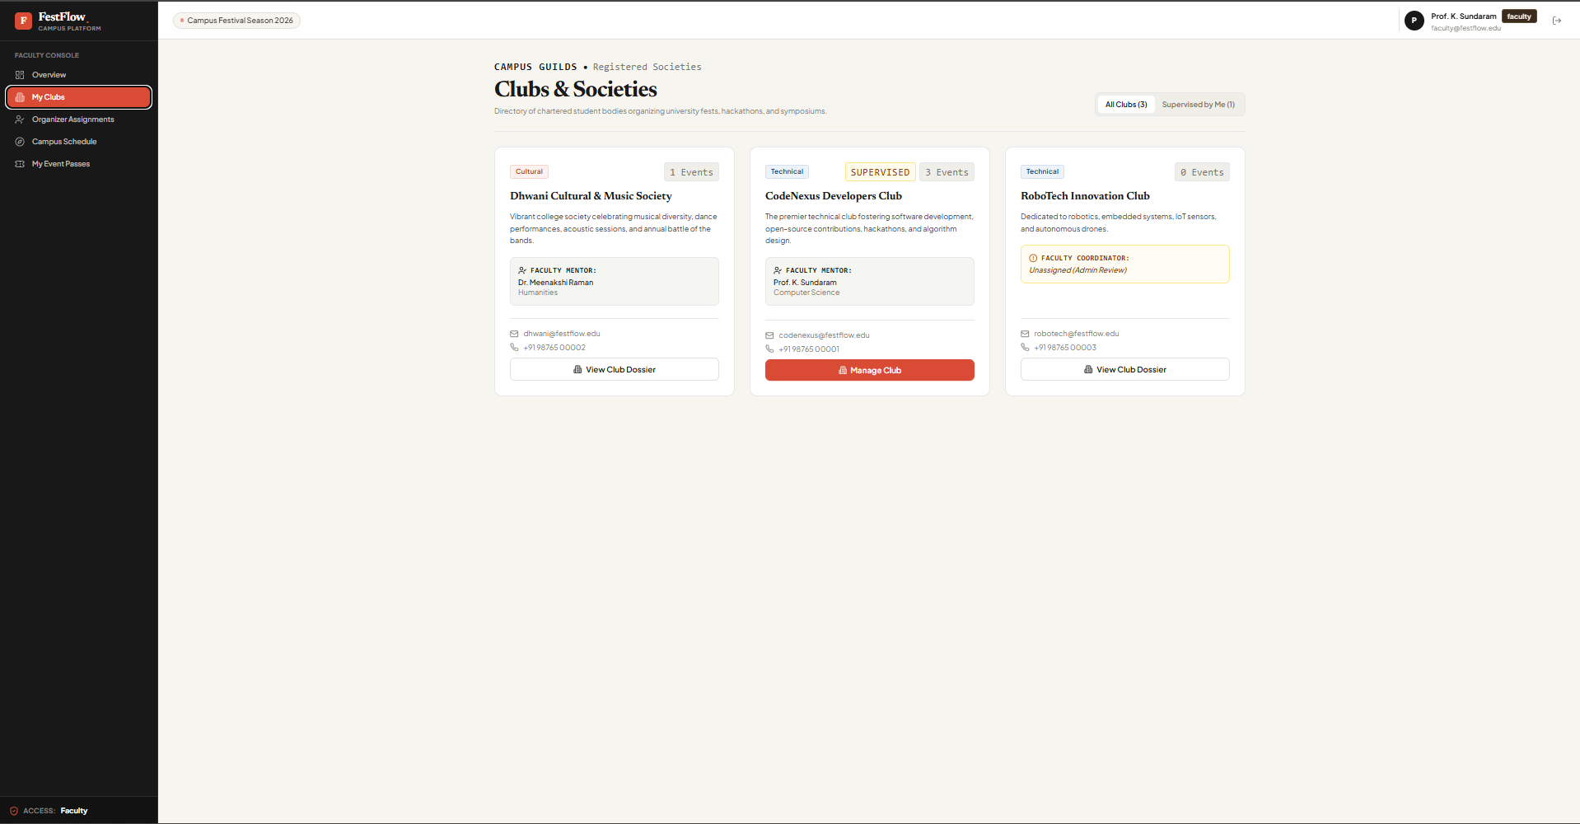
Figure 6. Club directory displayed in the student portal.
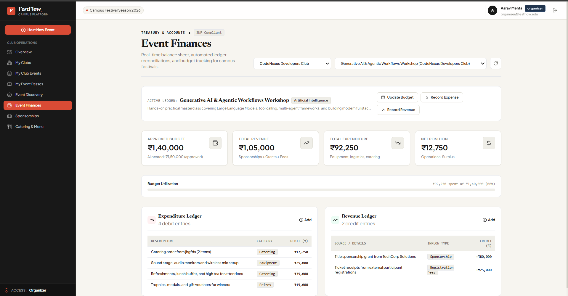
Figure 7. Event finance dashboard showing budget, revenue, expenditure and ledger entries.
The system combines student-facing functions with club administration and campus-level governance. The main modules are summarized below rather than describing every endpoint separately.
Module | Main functions | Primary data
Authentication and roles | Registration, login, JWT sessions and role-specific access. | Users
Event discovery and registration | Search events, check capacity, register, cancel and issue passes. | Events, Registrations, Venues, Payments
Club management | Club directory, member rosters and club-scoped event administration. | Clubs, ClubMemberships, Users
Faculty and administration | Supervise clubs, appoint/revoke organizers and create faculty accounts. | Users, Clubs, ClubMemberships
Finance and catering | Budgets, expenses, revenue, catering menus and dynamic totals. | Budgets, Expenses, Revenues, Caterings
Competitions | Teams, judging criteria, scores, prizes and leaderboards. | Competitions, Teams, Judges, Scores, Results
Certificates and feedback | Issue and verify certificates; collect event ratings and comments. | Certificates, Feedbacks
Volunteers and sponsors | Volunteer duties and shifts, sponsor records and event sponsorships. | Volunteers, Sponsors, EventSponsors

5. User Roles and Authorization
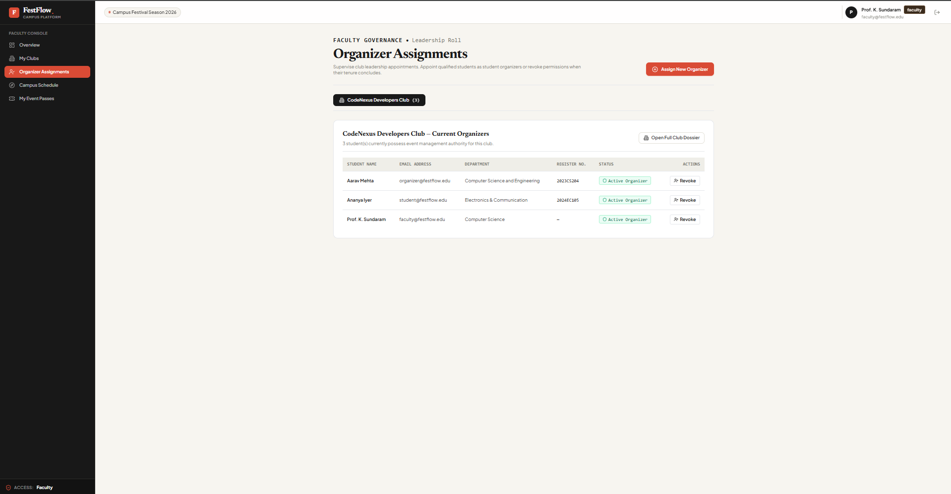
Figure 8. Faculty organizer-assignment workflow and current organizer roster.
FestFlow uses four roles: student, organizer, faculty and administrator. Permissions are checked on the server, rather than relying only on hiding interface controls. Organizers can manage events and finances for their assigned clubs. Faculty members are restricted to clubs they supervise, while administrators have campus-wide privileges.
Action | Student | Organizer | Faculty | Admin
Browse events and venues | Yes | Yes | Yes | Yes
Register for events | Yes | Yes | Yes | Yes
Manage events | No | Assigned clubs | No | All clubs
View financial records | No | Assigned clubs | Supervised clubs | All clubs
Appoint organizers | No | No | Supervised clubs | All clubs
Provision faculty accounts | No | No | No | Yes

The club authorization utility resolves which clubs a user may access. Attempts to modify an unrelated club’s events or financial records are rejected with HTTP 403. When a student is removed from their last organizer assignment, the system returns their role to student while preserving registration records and ticket passes.

6. Database Design
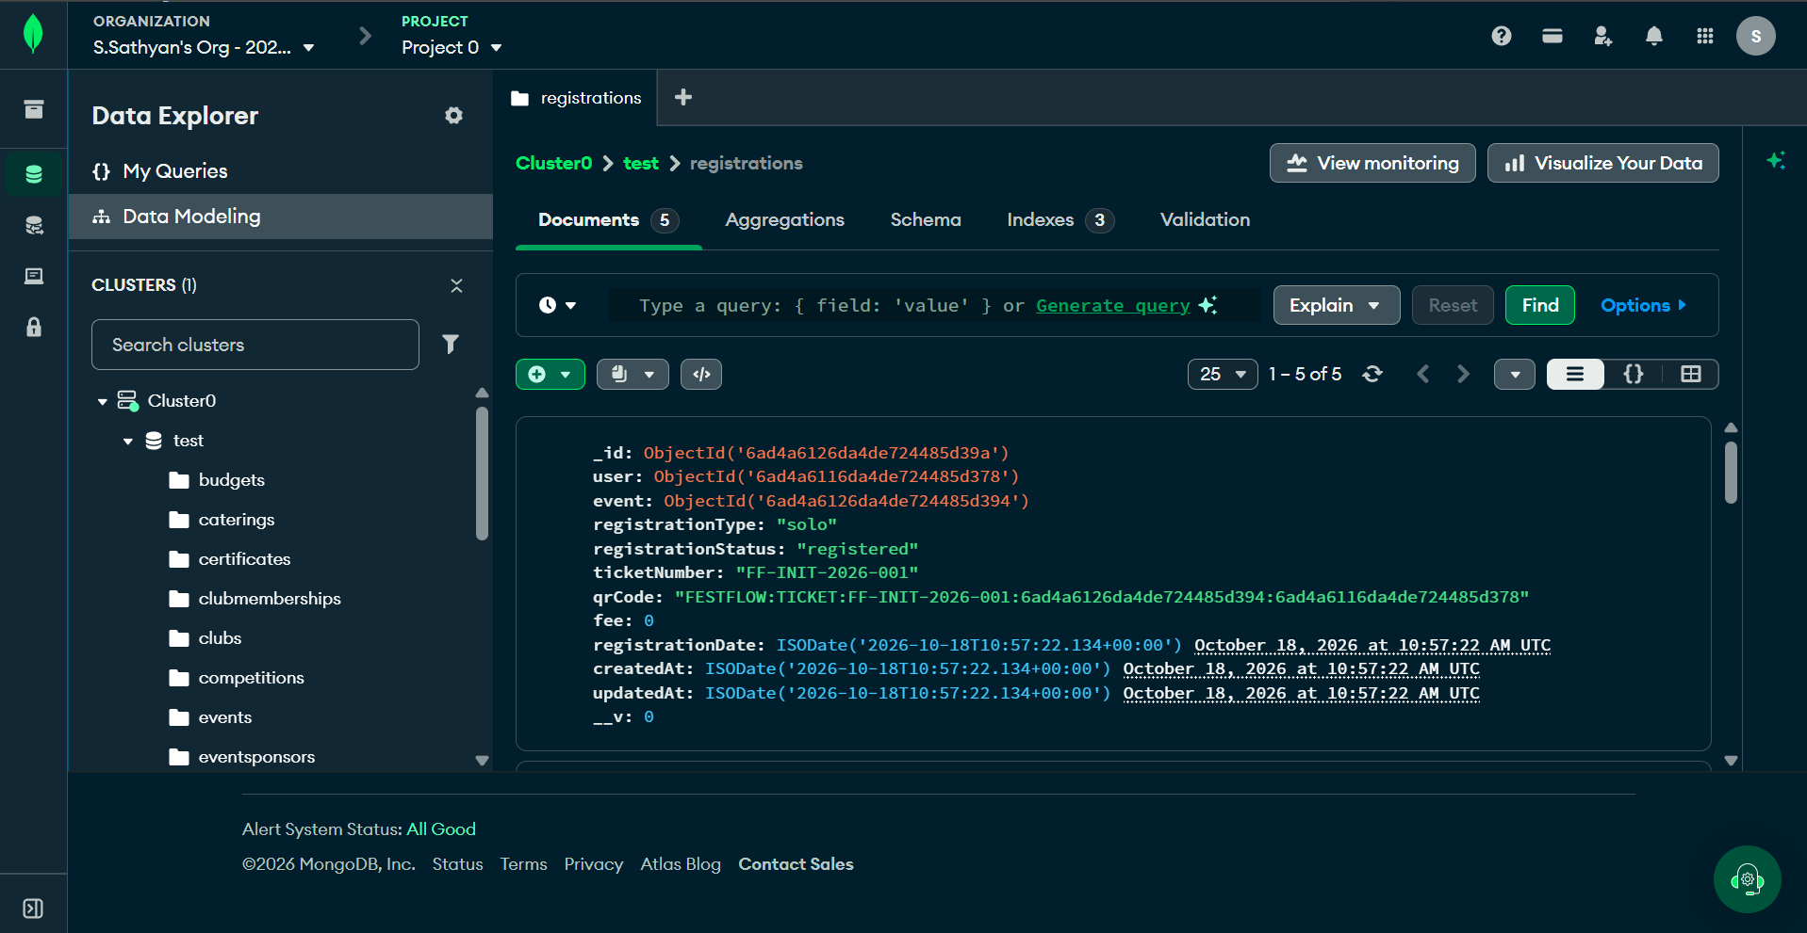
Figure 9. MongoDB Atlas collection view used to inspect stored application records.
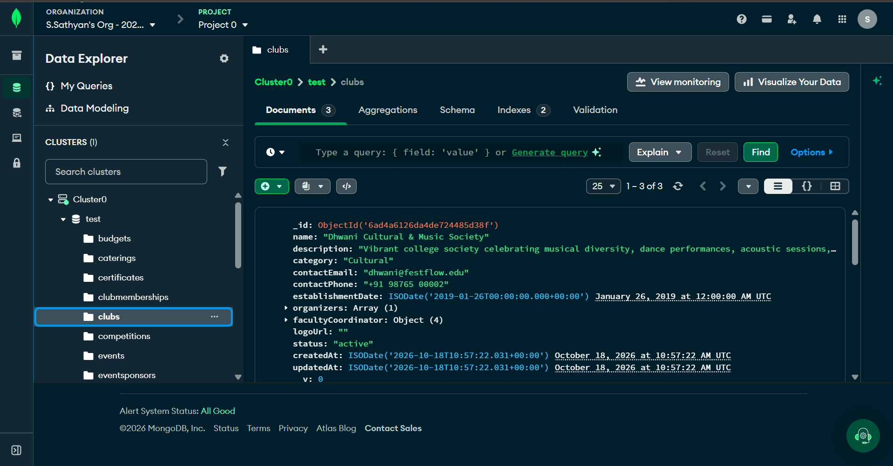
Figure 10. MongoDB Atlas database inspection view supporting index verification.
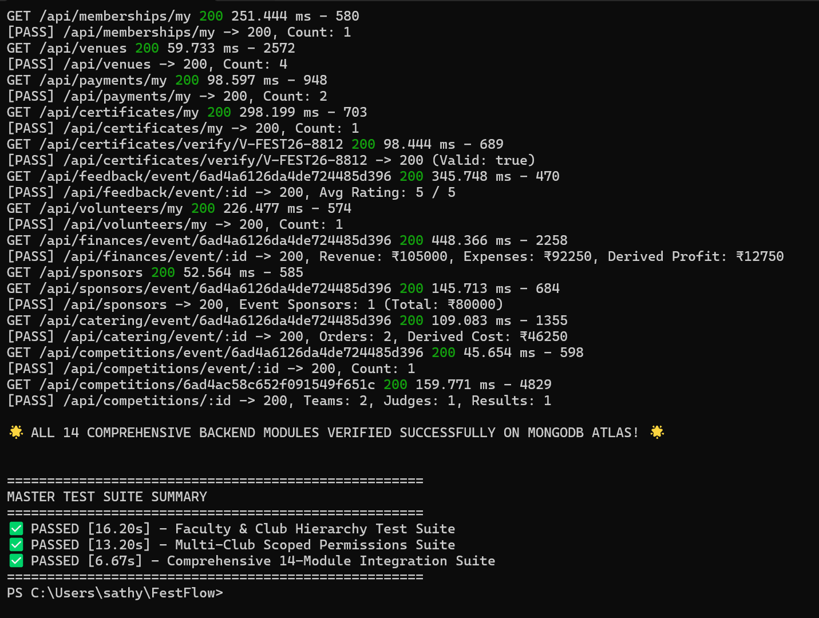
Figure 11. Financial aggregation output showing computed revenue and expenditure totals.
The live application stores data in MongoDB Atlas using Mongoose models. The technical reference reports 18 collections derived from 14 model files. Related documents are linked through ObjectId references, while selected small, structured groups—such as venue facilities, catering menu lines and competition team members—are embedded as subdocuments.

6.1 Main Collections and Relationships
Collection / entity | Purpose | Key relationships or constraints
Users | Accounts, roles and student profile data. | Unique email; role and active-status fields.
Clubs | Club identity, category, organizers and faculty coordinator. | References users; supports multiple club assignments.
Events | Schedule, category, capacity, fee and status. | References a club, venue and creator.
Registrations | Attendee registration and ticket pass. | Unique compound index on user and event; unique ticket number.
Venues | Campus venue details and seating capacity. | Capacity validation; structured facilities.
Budgets, Expenses, Revenues | Financial allocation and line-item accounting. | Linked to events; totals calculated dynamically.
Certificates, Feedbacks, Volunteers | Credentials, ratings and volunteer shifts. | Linked to events and users; uniqueness constraints where required.
Competitions and related records | Teams, judges, criteria, scores, prizes and results. | Linked to events and competition entities.
Sponsors and EventSponsors | Sponsor directory and event-specific sponsorships. | Connects sponsors with events and sponsorship details.

6.2 ER Diagram
The principal relationships are: a club organizes many events; each event is assigned a venue; users register for events through registration records; and event financial, certificate, feedback and volunteer records reference their related event and, where applicable, user. Junction-style collections such as registrations and event sponsorships represent many-to-many associations.

7. Normalization and Data Integrity
The project’s academic reference files include relational SQL schema, sample data and queries. These artifacts are intended for DBMS coursework; the active web application uses MongoDB Atlas and does not execute the SQL DDL at runtime. The design principles are therefore discussed in relation to both the live document model and the supplied relational reference.
Principle | Application in FestFlow
First Normal Form (1NF) | Structured fields and typed subdocuments are used instead of comma-separated values. Menu lines, venue facilities and team members contain separate attributes.
Second Normal Form (2NF) | Registration and membership associations separate relationship-specific data from the main user, club and event entities. The relational reference should be checked for composite-key dependencies.
Third Normal Form (3NF) | Financial totals, seat availability and catering totals are derived from their underlying records instead of being maintained as duplicate stored totals.

MongoDB is a document database, so relational normal forms are not applied mechanically to every embedded structure. The project uses normalization concepts to reduce redundant data and update anomalies, while embedding selected data where it is useful for the application. Compound unique indexes provide additional database-level protection against duplicate registrations, feedback and other repeated actions.

8. Security and Validation
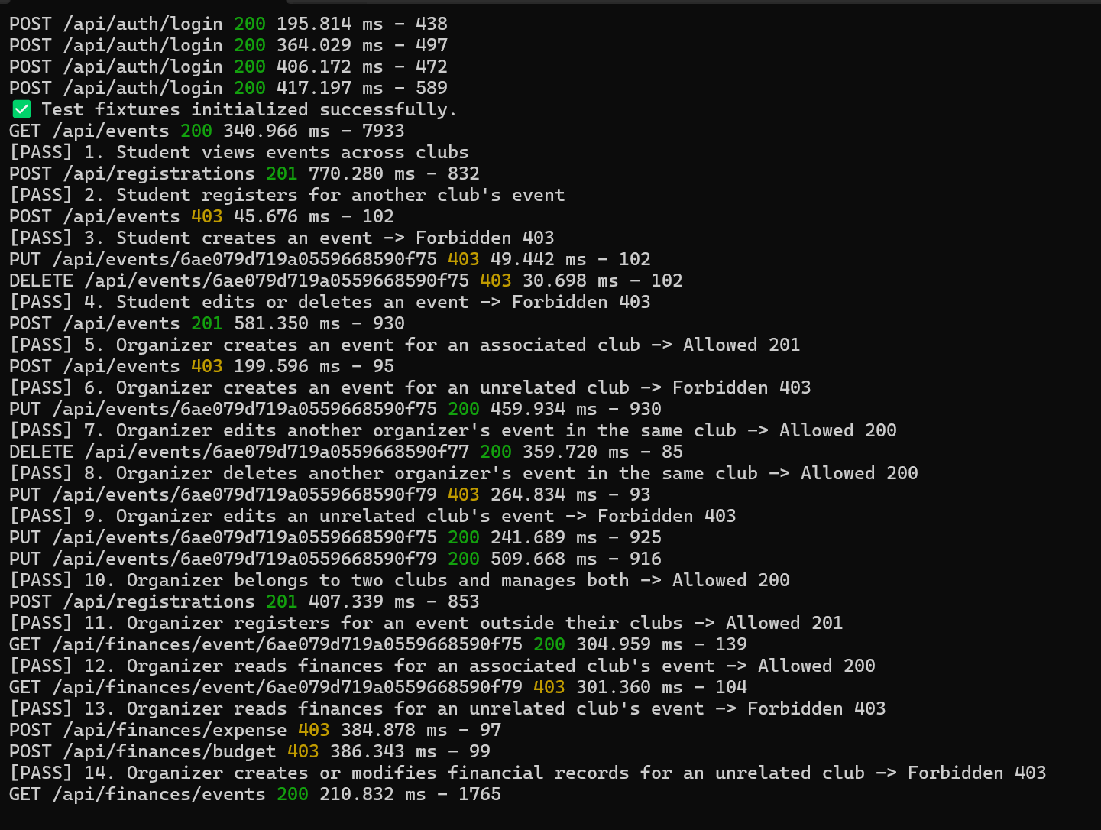
Figure 12. Authorization-boundary test output for protected application operations.
- JWT authentication: signed tokens identify the user and expire after the configured period.
- Password protection: bcryptjs hashes passwords using ten salt rounds; password fields are excluded from ordinary query results.
- Role checks: protected routes verify that the user’s role is permitted to perform an operation.
- Club-level authorization: event and finance queries are filtered to clubs assigned to the organizer or supervised by the faculty member.
- Unique indexes: prevent duplicate user–event registrations, ticket identifiers and selected transaction or feedback records.
- Environment hygiene: database credentials and JWT signing secrets are configured through environment variables and should not be committed to source control.

9. Testing and Verification
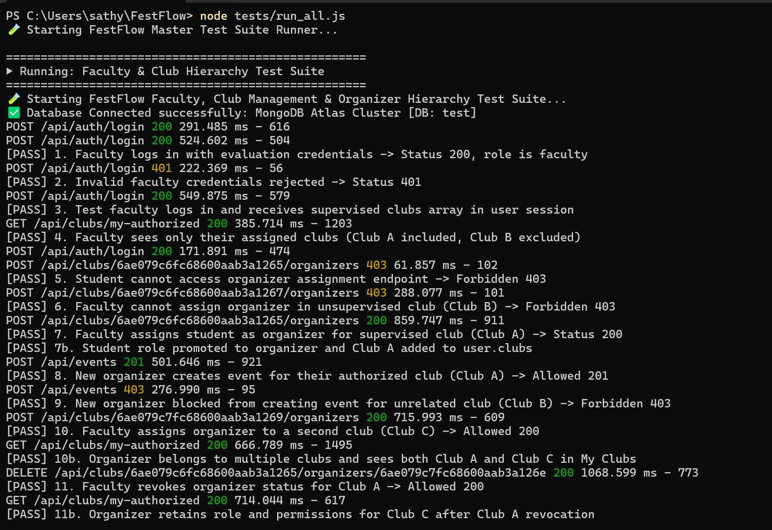
Figure 13. Automated test output covering faculty, club and permission workflows.
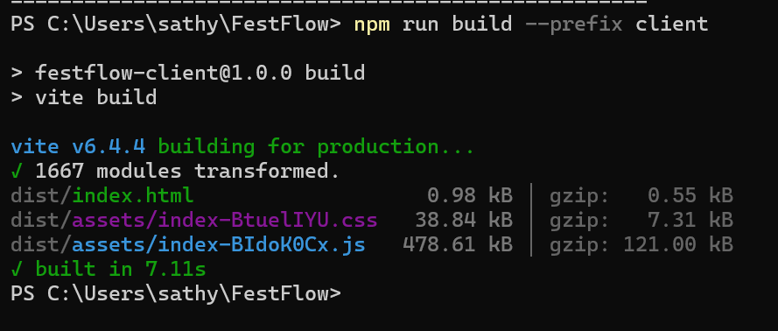
Figure 14. Frontend production build output from Vite.
The supplied test record states that the master test runner was executed on 27 October 2026. The three main suites cover faculty and club workflows, permission boundaries, and integration across the application’s modules.
Test suite / check | Passed | Failed | Recorded duration
faculty_and_clubs.test.js | 22 | 0 | 17.52 s
permissions.test.js | 17 | 0 | 11.89 s
runServerTest.js | 14 | 0 | 6.74 s
Master automated tests | 53 / 53 | 0 | 36.15 s total for listed suites
Frontend production build | Success | 0 build errors | 6.22 s

The tests cover authentication, role boundaries, organizer appointment and revocation, cross-club access blocking, financial data isolation, and integration across event-related modules. The client production build reportedly transformed 1,667 modules without build errors. These results are taken from the supplied project evidence and should be matched to the latest run before final submission.

10. Results and Discussion
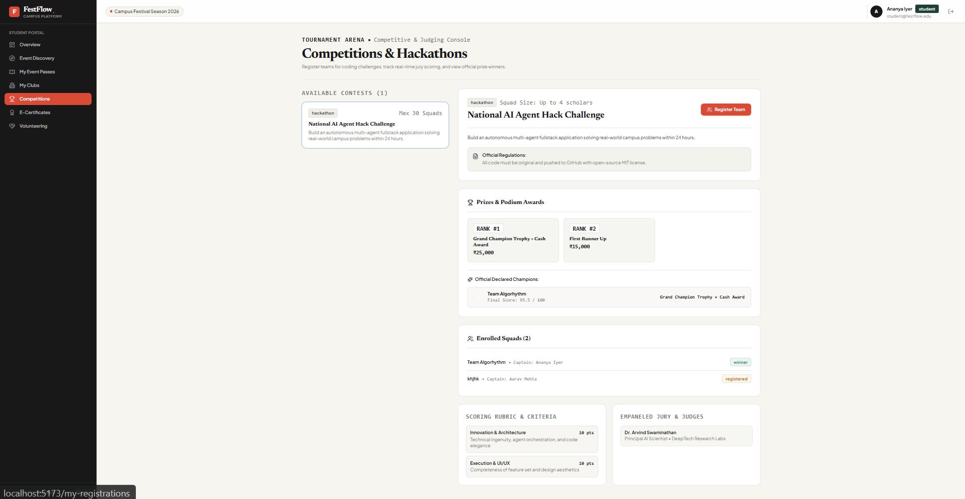
Figure 15. Competition and hackathon interface with teams, judging criteria and awards.
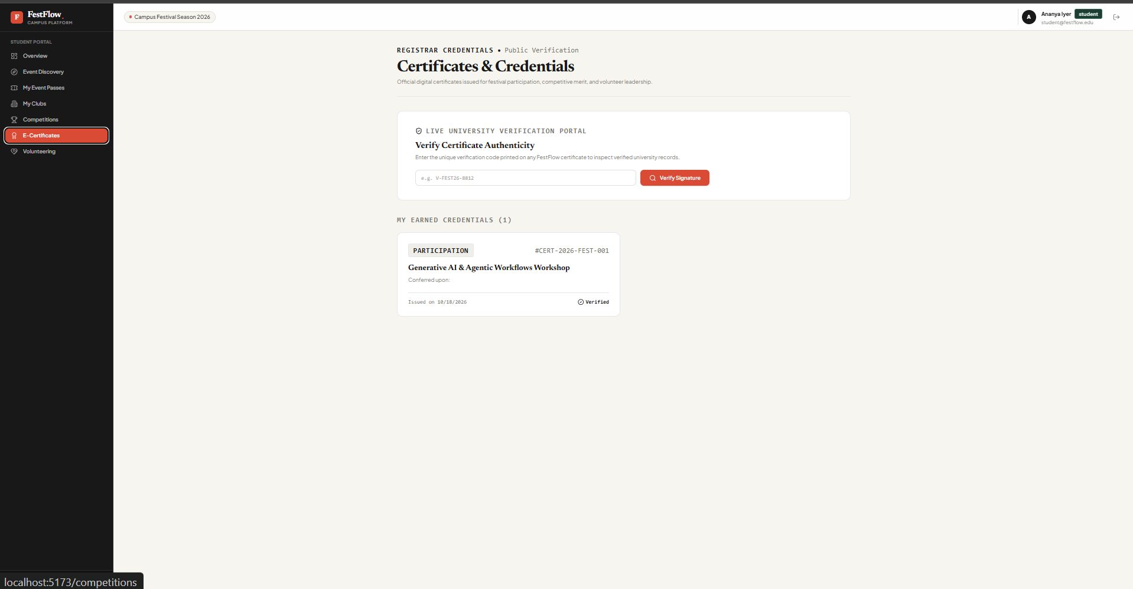
Figure 16. Certificate verification interface and earned credentials.
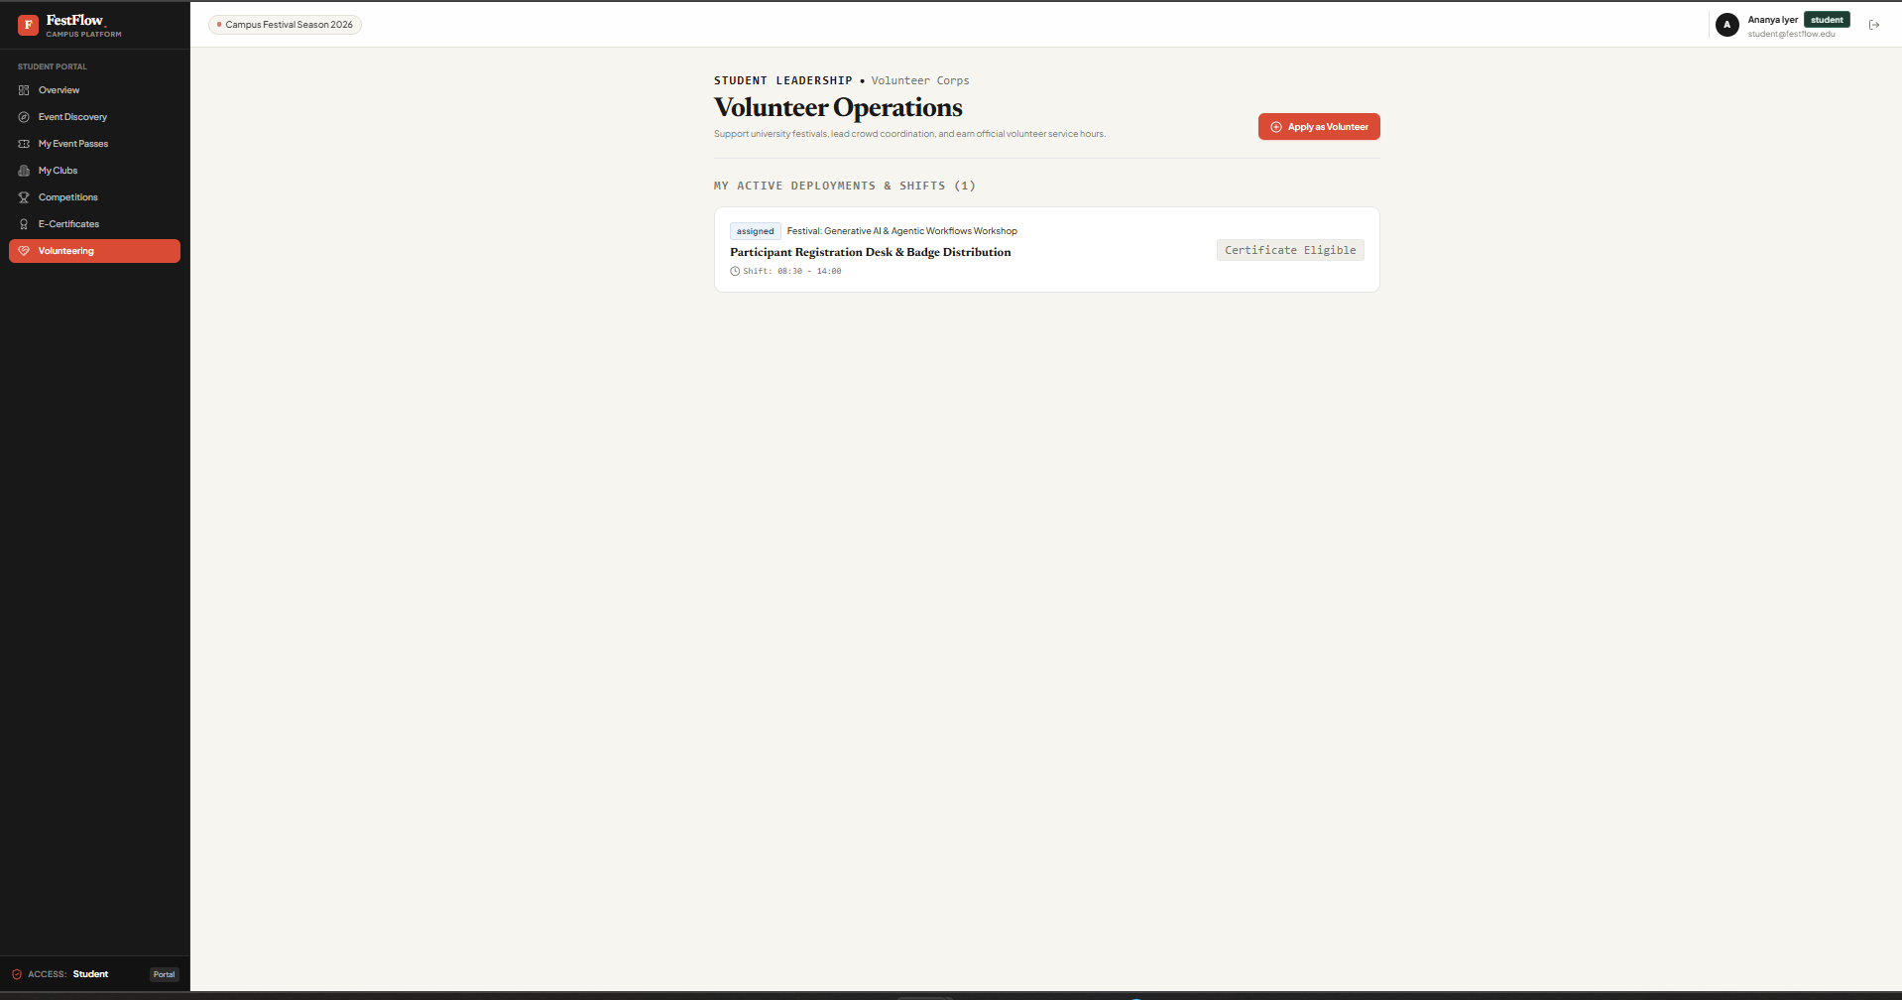
Figure 17. Volunteer operations page showing an assigned event shift.
Figure 18. Event finance dashboard with ledger summaries and budget utilization.
The recorded tests support the implementation of the main authorization and registration safeguards. The permission tests check that users cannot cross club boundaries, while the faculty and club tests exercise organizer assignment and safe demotion. The registration design combines application-level checks with a unique compound index on user and event to reduce duplicate registrations.
Financial summaries are derived from revenue and expense records through aggregation, so a change to an individual line item can be reflected in the displayed totals without updating a separately stored profit field. The system also includes certificate verification, volunteer scheduling, competitions and feedback modules, extending the application beyond basic event registration.
The current evidence is functional rather than a performance benchmark. No database throughput, latency-under-load or scalability measurements were supplied, so no such figures are claimed here.

11. Limitations and Future Enhancements
The following limitations are identified in the project notes:
- Payment records are supported, but a live payment gateway and verified settlement webhooks are not integrated.
- Email delivery for ticket confirmations and organizer appointments is not configured.
- JWTs are stored in browser local storage; HTTP-only cookies and refresh-token rotation could strengthen session security.
- Club images and event banners use remote URLs rather than a dedicated object-storage upload pipeline.
- The relational ANSI SQL files are academic reference artifacts; the deployed application uses MongoDB Atlas rather than a relational SQL engine.
Possible future work includes payment gateway integration, automated email delivery, cloud object storage for event media, and a mobile companion application for ticket scanning and check-in.

12. Conclusion
FestFlow brings event discovery, registration, club management, faculty supervision and financial tracking into one web application. Its database layer uses Mongoose schemas, references, validation and compound indexes to support consistent records, while aggregation pipelines derive financial and capacity summaries from the underlying data. The supplied test results report 53 passing automated tests and a successful production build. The project demonstrates how DBMS concepts—data integrity, relationship modelling, normalization principles, access control and derived queries—can be applied in a practical full-stack application.

References
[1] MongoDB, Inc., “MongoDB Manual.” [Online]. Available: https://www.mongodb.com/docs/manual/
[2] MongoDB, Inc., “Mongoose ODM Documentation.” [Online]. Available: https://mongoosejs.com/docs/
[3] OpenJS Foundation, “Express—Node.js Web Application Framework.” [Online]. Available: https://expressjs.com/
[4] React, “React Documentation.” [Online]. Available: https://react.dev/
[5] IETF, “JSON Web Token (JWT),” RFC 7519, May 2015. [Online]. Available: https://www.rfc-editor.org/rfc/rfc7519

